**Designs & Mechanism**

[**www.mark8hub.com**](http://www.mark8hub.com)

|  |  |
| --- | --- |
| 1. **Homepage** |  |

As aforementioned in the attached pdf, the descriptions are mentioned herewith:

* The “Top Bar” with menus like Site’s Logo, Site Name, Site’s Tagline, Single Search Bar, Home, Listings, Category, Pricing, Blog, Contact and Sign in will be Fixed. This segment shall be fixed for every pages at entire site. (We gave you overall web view but you did not point this one out) We will do that
* Then after the “Categories section” will be as it is. The size/space occupied by this section needs to be shorten down. Moreover re-think upon the design and attractiveness for better UI. (We told you to change UI. See your previous website and compare our work. No sliders work)
* The “Search Segment” to be brought upward so that the upcoming segment “Featured Business” will be previewed in the “first view of homepage”. (Please remember the day you yourself give us direction to do exactly the same)
* “Featured Listings/Business” segment needs mentioning of “City Name & District Name”. Further this segment shall be auto-sliding in every 5-10 seconds.

“Featured Products” will show the image, name, price and “i” icon only of a product. Name of product shall be shown at below of every image. Further, “i” icon and price shall be attached upon the image as shown in here below. When user clicks upon the “i” icon, the every detail of that product will be highlighted and shown (by blurring the background). (We will do that)

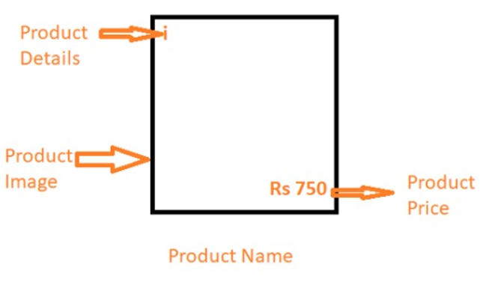

* The same above functionality will be applied to “Featured Services” segment. (We will do that)
* Then the “Brands We Recommend” section will be shown with brand image and name only. While clicking upon brand name/image the list of business houses shall appear who offers the said branded product. This feature will be hidden for now. (this feature will be hidden for now and you yourself said to do this later)
* The same should be beautifully arranged at mobile view. (See home page and branches page)

|  |  |
| --- | --- |
| 1. **Business House Profile View** |  |

As aforementioned in the attached pdf, the descriptions are mentioned herewith:

* The “Top Bar” with menus shall be fixed.
* The next segment will include Logo, Name of business house, Share option (so that the link to business house shall be shared to anyone via facebook, whatsapp, instagram, tweeter & custom link), latest award image (if any). (On call you said just copy Business profile page Link)
* The next segment will be the cover image of the business house. The cover image shall be well justified to maintain the better resolution. (Its working, that’s not my task to say to users to upload high resolution image)
* The next segment will include the “Ribbon Bar” below cover image. The ribbon bar will include portions like “About Us, Products & Services, Offers, Branches, Brands, Awards”. These portions will be equally justified within the ribbon. (Offers section will be hidden for now) (Its working)
* Under About us firstly the icons like “Call us, Follow us, Ask Quotation, Website Link”. Further on click at “Call us” icon, the call shall be made or the contact number will be shown (for desktop users). On click upon “Follow Us”, the user shall be listed under follower of the specified business house and in near future if the business house updates any “offers”, same shall be notified to follower. (We will do that) ask this point with Amuliya
* On click upon “Quotation”, a blank page will appear wherein the user shall fill up the particulars and submit. At reply of which the business house will fill the particulars with price and revert back. The reply of quotation shall be forwarded automatically to the user’s mail ID. (Need time to implement)
* Upon Click at “Website Link”, the linked official website of the business house will be opened in new tab.
* Next Segment includes basic details of the business house like: Category of Business, Group of Business, Contact Address, Email ID, Social Media Link (Facebook, Instagram etc).
* Then appears the Address of the business in written format (Biratnagar 13, Roadcess Street, Morang, Nepal). At below of which, the Google Map Location shall be shown (navigation facility should be provided.) (we will check this if not we will do that)
* Simultaneously the “Amenities, Opening Hours, Reviews” etc shall be plotted as shown in the image.
* The “Description and Gallery“ Section will be kept at Right side of the page. Agent detail shall be plotted at very end only.

|  |  |
| --- | --- |
| 1. **Add Product & Service Mechanism** |  |

As aforementioned in the attached pdf, the descriptions are mentioned herewith:

* In order to add product, service and product & service firstly while clicking upon the “products & services” menu under Dashboard, the specified form will appear.
* In the form, the user will select the directory at first.
* Then fill up the details of product/service and click on submit. The said product/service will be updated at profile of Business house.
* If one desires to add new product/service, he/she will click upon “Add Product/Service” section and the new form will appear with “Remove Product/Service” Option.
* The form for “Products/Services” will include options as specified in the attached pdf. “+” sign refers to image upload option (maximum 5 images).
* For “Services” an option called “Booking” shall be placed. Wherein the customer can click and book the listed services for specific Date & Time. (Check its working)

|  |  |
| --- | --- |
| 1. **Add Branch Mechanism & Branch View at Profile** |  |

* While adding branch of a business the user will select directory at first and will input only basic details as shown in the “Add Branch Mechanism”. And submit.
* And the View of the branches shall be as shown in the “Branch View at Profile”. Wherein the “Map” segment will be fixed, however while clicking upon the specific branch name the map of same branch needs to be shown at map. And clicking upon another “branch name” the respective map will be shown. (We have discuss this one)

|  |  |
| --- | --- |
| 1. **Brand Section and Awards Section** |  |

* Both the “Brand we offer” and “Awards” Section are same in nature. And needs to be plotted with two basic detail only. They are “Brand name, Brand Image” and “Award Name, Award Image”.